WEEK 6
Metal Welding
- Oxyacetylene Welding
  - Uses a flame from an oxygen-acetylene gas mixture.
  - A filler rod is melted into a weld pool on the parent metal.
  - Common for manual, portable welding tasks.
- Metal Inert Gas (MIG) Welding
  - Uses a consumable wire electrode with a gas shield (usually Argon).
  - An electric arc melts the electrode to form the weld.
  - Suitable for automated and high-speed welding.
- Electron Beam Welding
  - A focused electron beam melts the metal in a vacuum.
  - Deep and precise welds, with minimal distortion.
  - Requires close fit-up; used in aerospace/nuclear sectors.

🧱 Ceramic Welding
- Diffusion Bonding
  - Applies high pressure and temperature in a furnace.
  - Materials join without melting; atoms diffuse across the bond line.
  - Ideal for ceramics and dissimilar material joints.

🧵 Polymer Welding
- Induction Welding
  - Uses an induction coil to generate heat in a metal insert.
  - Thermoplastics are fused around the heated insert.
  - Common for joining tubes in plastic systems.
- Laser Welding (Polymer)
  - A laser beam focuses on a polymer sheet with a light-absorbing dye.
  - Heat melts and fuses the layers at the weld line.
  - Enables clean, precise polymer joints.

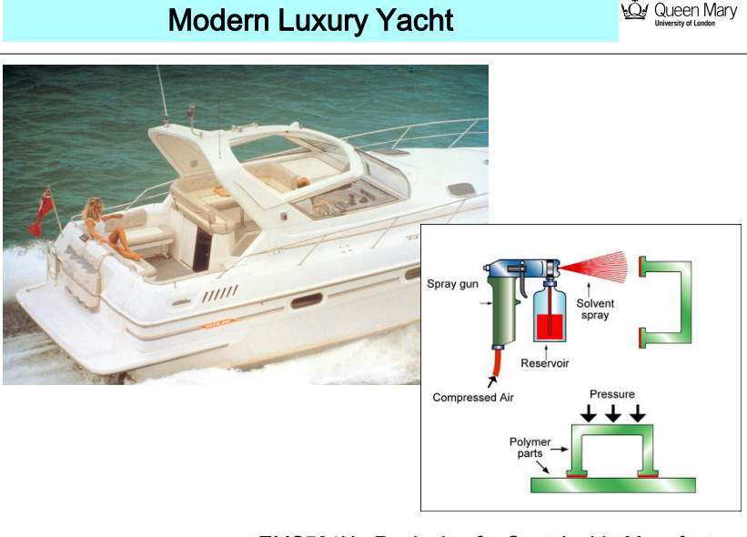
No External Bolts or Holes
- In traditional assembly, you'd see mechanical fasteners (bolts, rivets) that pierce through flanges.
- This method weakens the structure and disrupts the smooth outer surface (bad for aesthetics & aerodynamics).
Flanged Polymer Parts with Adhesive Bonding
- Instead of bolting, the yacht's panels are designed with flanges that fit together like puzzle pieces.
- A solvent-based adhesive is sprayed using a compressed air spray gun.
- The adhesive is applied within the flange seam — all around the part.
- Pressure is applied to hold parts together during curing.
Advantages:
- No visible joins or holes → sleek, waterproof surface.
- Stronger joints → avoids stress concentration from bolt holes.
- Lightweight and corrosion-resistant → ideal for marine applications.
- Cleaner aesthetic → luxury finish.
TYPES OF ADHESIVE
Types of Adhesive - Explained
1. Cyanoacrylate (Super Glue)
- Very fast-setting, bonds in seconds.
- Great for small parts, plastics, rubber, and skin.
- Brittle under shock or high heat.
- Cures with moisture in the air.
2. Epoxy
- Two-part adhesive: resin + hardener.
- Very strong, durable, resistant to chemicals and heat.
- Excellent for metal, composites, and structural bonding.
- Slow to cure (minutes to hours).
3. Polyurethane
- Flexible and durable.
- Bonds a wide range of materials: metal, wood, plastics, glass.
- Moisture-cured and often used in construction and automotive.
4. Silicone
- Flexible, rubbery adhesive.
- Excellent for sealing joints in moist or high-temperature environments.
- Common in electronics, kitchens, and windows.
5. Anaerobic Adhesives
- Cure in the absence of air (oxygen).
- Used to seal threads, gaskets, and bearings (e.g., Loctite).
- Great for metal-metal joins.
6. Toughened Acrylic
- Modified acrylics for improved toughness.
- Excellent impact resistance and strong bonding.
- Used in aerospace, automotive, and sports equipment.
7. Phenolic
- Thermosetting resin, often used as a binder in wood products (e.g., plywood).
- High-temperature resistance, but brittle.
- Used in aerospace composites and laminates.
8. MS Polymer (Modified Silane Polymer)
- Hybrid adhesive combining silicone and polyurethane properties.
- UV and weather resistant.
- Used in construction and transport (e.g., trains, yachts).
9. Polysulphide
- Flexible, resistant to fuels and chemicals.
- Ideal for aerospace fuel tanks, marine sealing.
- Cures slowly.
10. Hot Melt
- Thermoplastic adhesive applied hot (melted), then solidifies on cooling.
- Quick bonding, used in packaging, crafts, and furniture.
- Low strength but fast and clean.
11. PVA (Polyvinyl Acetate)
- White glue / wood glue.
- Common in woodworking, paper, and crafts.
- Water-based and easy to use, but weak in wet or hot conditions.
12. UV Cure
- Cures (hardens) when exposed to ultraviolet light.
- Used in electronics, glass, and medical devices.
- Fast and precise with clear adhesives.
Adhesive | Key Use Area | Strength | Cure Time | Special Trait
Cyanoacrylate | Quick fixes, small parts | High | Seconds | Moisture-cured
Epoxy | Structural bonding | Very High | Slow (hrs) | Heat/chemical resistant
Polyurethane | Versatile construction | Medium | Medium | Flexible, waterproof
Silicone | Sealing in moist environments | Low | Slow (24 hrs) | Flexible, high-temp
Anaerobic | Thread locking in metals | Medium | Slow | Cures without air
Toughened Acrylic | Aerospace, impact resistance | High | Medium | Shock-resistant
Phenolic | Composites, wood panels | High | Heat required | Brittle, heatproof
MS Polymer | Building & transport | Medium | Medium | UV/weather resistant
Polysulphide | Aerospace, marine | Medium | Slow | Fuel/chemical resistant
Hot Melt | Packaging | Low | Seconds | Fast, low strength
PVA | Wood, crafts | Low | Slow | Water-soluble
UV Cure | Electronics, medical | Medium | Seconds (w/UV) | Needs UV light to cure
1. Polyurethane
- Requirements: Moisture to cure (some are two-part).
- Strengths: Flexible, impact resistant, good for bonding different materials.
- Uses: Automotive, construction, footwear.
- Surface prep: Clean, may require primer for some plastics or metals.

2. Epoxy
- Requirements: Two-part mix (resin + hardener).
- Strengths: Very strong, chemical and heat resistant.
- Uses: Structural bonding in aerospace, electronics, marine.
- Surface prep: Clean, roughened surface improves bond.

3. MS Polymer (Modified Silane)
- Requirements: Cures with moisture.
- Strengths: UV resistant, flexible, paintable.
- Uses: Construction, sealing, bonding of panels.
- Surface prep: Clean, dry, some primers may be used.

4. PVA (Polyvinyl Acetate)
- Requirements: Water-based, cures as water evaporates.
- Strengths: Easy to use, non-toxic.
- Uses: Woodworking, paper, fabrics.
- Surface prep: Clean, dry, porous surfaces preferred.

5. Polysulphide
- Requirements: Often two-part, cures chemically.
- Strengths: Flexible, fuel-resistant.
- Uses: Aerospace, glazing, marine sealants.
- Surface prep: Clean, primer may be required for some substrates.

6. Cyanoacrylate (Super Glue)
- Requirements: Moisture in air to cure.
- Strengths: Rapid bonding, strong in tension.
- Uses: Plastics, rubbers, electronics, medical devices.
- Surface prep: Dry and clean; acidic surfaces can slow cure.

7. UV Cure
- Requirements: UV light exposure to cure.
- Strengths: Fast cure, precision bonding.
- Uses: Medical, electronics, glass.
- Surface prep: Transparent or UV-transmitting surfaces.

8. Anaerobic
- Requirements: Absence of oxygen and presence of metal ions.
- Strengths: Cures between metal parts (threadlockers, flange sealants).
- Uses: Mechanical assemblies (bolts, shafts).
- Surface prep: Clean metal surfaces, no large gaps.

9. Toughened Acrylic
- Requirements: Two-part, or primer-activated systems.
- Strengths: Tough, fast, can bond oily surfaces.
- Uses: Automotive, aerospace, structural bonding.
- Surface prep: Minimal, tolerates surface contaminants.

10. Silicone
- Requirements: Cures with moisture or heat.
- Strengths: Flexible, high-temperature and chemical resistant.
- Uses: Electronics, automotive, cookware, seals.
- Surface prep: Clean surfaces, sometimes a primer is used.

11. Hot Melt
- Requirements: Heat applied to melt adhesive, cools to solidify.
- Strengths: Fast setting, easy application.
- Uses: Packaging, furniture, textiles.
- Surface prep: Clean and dry; mostly for porous or non-critical surfaces.

12. Phenolic
- Requirements: Heat and pressure to cure (thermosetting).
- Strengths: Very high temperature and chemical resistance.
- Uses: Aerospace, electronics, industrial composites.
- Surface prep: Clean, often requires pressure bonding during cure
What is Surface Wetting?
Surface wetting describes how well a liquid (like glue or paint) spreads out on a surface. Good wetting = strong bond.
- Higher surface energy → better wetting → stronger adhesive bonding.
- Low surface energy (e.g. PTFE/Teflon) resists wetting — glue rolls
Types of Loads & Stress Distribution
Left Side: Types of Loads on Joints
These show different ways adhesive joints can be stressed:
- Tensile Load (pulling apart directly) – good distribution
- Shear Load (sliding past each other) – good
- Compressive Load – also well distributed
- Peel Load (one side lifting away) – very poor
- Cleavage Load (prying open) – very poor
✅ Good loads (tensile, shear, compressive) spread stress evenly.
❌ Bad loads (peel, cleavage) create stress peaks at the ends, which can cause early failure.

Right Side: Stress Distribution Graphs
These charts show how stress is spread across the bond area:
- Ideal: flat line – stress evenly distributed.
- Peel/Cleavage: stress is concentrated at the edge → leads to crack initiation.

🔍 Slide 2: Design to Reduce Stress Peaks
This slide shows bad vs. improved joint designs when peel or cleavage loads are unavoidable.
Left Column: Peel Load Problems
- Joints stressed in peel (e.g., top flaps being peeled open).
- Leads to concentrated stress at the edge.
Right Column: Better Design Solutions
- Add flanges, fillets, or overlaps to redirect the load from peel → to shear or compression.
- Wrap the adhesive around the load path so it's not peeling but being sheared.
- Use continuous bonding areas rather than single-point joins.
✅ Key Takeaways
- Avoid peel and cleavage stresses in design.
- Distribute loads across large areas, preferably in shear or compression.
- Use smart geometric design (like overlaps or wraps) to redirect forces.
- Minimising stress peaks extends the life and safety of adhesive joints.
ROD AND TUBE JOINT DESIGN
Straight Butt Joint
🧩 Use: Good for rods in tension and compression.
⚠️ Weakness: Poor in bending unless the bond area is large.
✅ Simple but not good for flexing loads.
2. Angled Insertion Joint
🧩 Use: Good for rods only (not tubes).
✅ Angled insertion gives some mechanical interlock.
⚠️ Requires precise shaping.
3. Tube-in-Tube (Socket) Joint
🧩 Use: Good for rods, where one part fits inside another.
✅ Easy to align, has moderate bonding area.
⚠️ May not suit all diameters.
4. Sleeved Lap Joint
🧩 Use: Works well for rods or tubes.
✅ Balanced and stronger due to large contact area.
⚠️ Slightly more complex to fabricate.
5. Tapered Insertion Joint
🧩 Use: Generally poor for tubes.
⚠️ Tapered ends can focus stress and reduce strength.
❌ Avoid in critical structural joints.
6. Pinned Collar Joint
🧩 Use: Good for rods but slower to produce.
✅ Adds mechanical fixing (pin) for added strength.
⚠️ More time-consuming, better for high-strength needs.
7. Threaded End Joint
🧩 Use: Good for tubes if wall thickness allows machining.
✅ Secure and removable connection.
⚠️ Requires precision cutting and thicker walls.
8. Elbow Joint
🧩 Use: For corners in rods or tubes.
✅ Elbows offer neat 90° redirection.
⚠️ Best used with prefabricated elbow fittings for strength and ease.
Cylindrical Bonding
🔧 What is it?
- A method of joining cylindrical parts (e.g. gears, shafts) using press-fit + adhesive.
- Commonly used in Scania truck gearboxes, where gear sets are press-bonded onto a countershaft.
💡 How it works:
- One part is slightly larger and pressed into another (interference fit).
- An anaerobic adhesive (like Loctite) fills microscopic gaps.
- It cures in the absence of oxygen, forming a solid bond.
✅ Advantages:
- Even load distribution across the surface.
- Prevents fretting (microscopic movement leading to wear).
- High torque resistance without machining keyways or splines.
Threadsealing
🔧 What is it?
- Involves applying sealant to threaded parts (nuts, bolts, pipe threads).
- Prevents leakage of gases or fluids under pressure.
🛢️ Example shown:
- Petrol pump thread sealing — a safety-critical application.
- Uses anaerobic adhesives designed to:
  - Fill gaps between threads,
  - Prevent leaks,
  - Lock threads in place to resist vibration loosening.
✅ Advantages:
- Leak-proof and vibration-proof.
- Chemical and pressure resistant.
- No need for tapes or mechanical seals.

Additive Manufacturing Techniques Summary
Technique | How It Works | Key Feature | Typical Materials | Example Applications
Selective Laser Sintering (SLS) | A laser selectively sinters powdered polymer, layer by layer. | Laser sinters powder layer-by-layer (polymers) | Nylon, ABS, polycarbonate | Power tool housings, circuit breakers, aerospace handles
Selective Laser Sintering of Metals | A laser partially melts metal powder layer-by-layer. The porous part is then infiltrated with bronze. | Laser sinters metal powder, then infiltrated with bronze | Stainless steel, titanium + bronze | Injection mould tools with cooling channels, die casting moulds
Stereo-lithography (SLA) | A UV laser cures layers of liquid photopolymer resin. | Uses UV light to cure liquid photopolymer | Photopolymers (acrylates) | Phone cases, implants, EDM electrodes
Laminated Object Manufacturing (LOM) | Layers of material are bonded and laser-cut into shape. | Bond and laser-cut sheets layer by layer | Paper, polymer, metal sheets | Casting moulds, automotive mock-ups
Solid Ground Curing (SGC) | UV light cures resin through masks to form each layer simultaneously. | UV-curing resin through masks, layer by layer | Photosensitive resin, wax | Detailed prototypes, electronics enclosures
Fused Deposition Modelling (FDM) | A heated nozzle extrudes molten thermoplastic filament. | Heated nozzle extrudes thermoplastic filament | ABS, Nylon, PLA | Rapid part prototypes, functional models
Ballistic Particle Manufacturing (BPM) | Molten droplets are jetted by piezo system and solidified layer by layer. | Molten droplets jetted by piezo system and frozen | Thermoplastics | Experimental rapid prototyping
3D Printing (Inkjet-based) | Inkjet heads deposit tiny polymer droplets layer by layer. | Multiple jets deposit polymer like an inkjet printer | Thermoplastic polymer | Basic concept models and fast prints

